**UNIT 5**

**Introduction to Neural Networks: Neurons and Neural Nets**

Neural networks are a class of machine learning models inspired by the structure and functioning of the human brain. These networks are designed to recognize patterns and make predictions based on data. They are particularly powerful for tasks such as image recognition, speech recognition, natural language processing, and even in complex fields like robotics and healthcare.

### ****1. Neurons: The Building Blocks of Neural Networks****

A **neuron** in a neural network is a mathematical function that takes one or more inputs, processes them, and produces an output. It is analogous to biological neurons, which receive electrical signals from other neurons, process the information, and send out a signal to other neurons.

A simple **artificial neuron** consists of the following components:

* **Input (x₁, x₂, ..., xn)**: These are the features of the data that the neuron will process. For example, in an image recognition task, the inputs could be pixel values of an image.
* **Weights (w₁, w₂, ..., wn)**: Each input has an associated weight that represents its importance in the decision-making process. These weights are learned during the training process.
* **Bias (b)**: This is an additional parameter that allows the neuron to shift the activation function. It helps the model make decisions that are not strictly based on the weighted sum of the inputs.
* **Activation Function (f)**: This is a mathematical function that determines the output of the neuron. It introduces non-linearity into the network, which is essential for learning complex patterns.

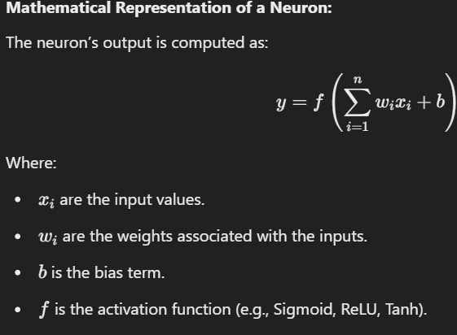

### ****2. Neural Networks: A Collection of Neurons****

A **neural network** is a collection of multiple neurons arranged in layers. The most basic type of neural network is a **feedforward neural network**, where information flows in one direction, from input to output, without loops.

Neural networks can be composed of three main types of layers:

1. **Input Layer**: This layer receives the input features of the data. For example, in an image classification task, the input layer will take pixel values of the image.
2. **Hidden Layers**: These are layers between the input and output layers. The hidden layers perform the computations and transformations needed to learn patterns in the data. A neural network can have multiple hidden layers, and these layers are where most of the learning happens.
3. **Output Layer**: This layer produces the final output of the network. For example, in a classification task, the output layer may have one neuron per class, and the output values represent the probabilities of each class.

### ****Types of Neural Networks****

* **Feedforward Neural Networks (FNNs)**: Data flows from input to output in one direction, with no feedback loops.
* **Convolutional Neural Networks (CNNs)**: Specially designed for processing grid-like data (e.g., images). They use convolutions to capture spatial hierarchies and patterns in the data.
* **Recurrent Neural Networks (RNNs)**: Designed for sequence data (e.g., time series, speech). They have loops that allow information to be passed from one step to the next.

**Working of a Neural Network**

• **Input Layer**:

* Suppose the inputs are x1=0.6x_1 = 0.6x1​=0.6 and x2=0.4x_2 = 0.4x2​=0.4.

• **Hidden Layer**:

* Neuron 1 in the hidden layer takes x1x_1x1​ and x2x_2x2​, applies weights w1w_1w1​, w2w_2w2​, and adds bias b1b_1b1​. The output of Neuron 1 is then passed through an activation function (say, ReLU or Sigmoid).
* Similarly, Neuron 2 performs the same operation with its own set of weights and biases.

• **Output Layer**:

* The outputs from the hidden layer are then passed to the output layer, which computes the final output. This output might be a probability, indicating the likelihood of a positive outcome (e.g., purchase).

• **Training the Network**:

* During training, the network adjusts its weights using a process called **backpropagation** combined with an optimization algorithm like **gradient descent**. The goal of training is to minimize the difference between the predicted output and the actual output (i.e., minimize the error).

### Neural Network Structures for Pattern Recognition (PR)

Neural networks are widely used in pattern recognition (PR) due to their ability to learn complex relationships from data. They can be used for various tasks like classification, regression, clustering, and anomaly detection. Below is an overview of the different neural network structures typically used in pattern recognition applications:

#### 1. **Feedforward Neural Networks (FNN)**

* **Structure**: Composed of layers of neurons where the information flows in one direction, from input to output.
* **Applications**: Used in basic classification and regression tasks like handwritten digit recognition, medical diagnosis, and time-series prediction.
* **Key Features**: Simple architecture with input, hidden, and output layers. Training is typically done using backpropagation.

#### 2. **Convolutional Neural Networks (CNN)**

* **Structure**: Comprised of convolutional layers that apply filters to the input data, pooling layers to reduce dimensionality, and fully connected layers for classification.
* **Applications**: Primarily used in image and video recognition, including object detection, facial recognition, and image segmentation.
* **Key Features**: Efficient at learning spatial hierarchies of features. CNNs are the go-to architecture for visual pattern recognition tasks.

#### 3. **Recurrent Neural Networks (RNN)**

* **Structure**: Contains loops within the network to allow information persistence. It can take sequential data as input and retain past information.
* **Applications**: Used for tasks that involve sequential data, such as speech recognition, language modeling, machine translation, and time-series forecasting.
* **Key Features**: Great for handling temporal dependencies and sequential patterns.

#### 4. **Long Short-Term Memory (LSTM) Networks**

* **Structure**: A special type of RNN that uses gating mechanisms to capture long-range dependencies and prevent vanishing gradient problems.
* **Applications**: Applied in tasks involving long-term dependencies like language translation, sentiment analysis, and video captioning.
* **Key Features**: Can learn dependencies over long sequences of data. LSTMs are widely used in natural language processing (NLP).

### Applications of Neural Networks in Pattern Recognition (PR)

1. **Image and Object Recognition**:
   * Neural networks, particularly CNNs, have revolutionized image classification tasks. Applications include facial recognition, traffic sign detection, and medical imaging (e.g., tumor detection).
2. **Speech Recognition**:
   * RNNs, and specifically LSTMs, are used to recognize spoken language, transcribe audio into text, or identify speech patterns in real-time.
3. **Natural Language Processing (NLP)**:
   * RNNs, LSTMs, and Transformer networks are key for tasks like sentiment analysis, machine translation, and question answering.
4. **Anomaly Detection**:
   * Autoencoders and CNNs are applied in identifying unusual patterns in data, such as fraud detection, equipment malfunction prediction, and cybersecurity threats.
5. **Time-Series Prediction**:
   * RNNs and LSTMs are used to forecast future events based on historical data, such as stock market predictions, weather forecasting, and demand forecasting.

### Physical Neural Networks

Physical neural networks are a specialized type of neural network where the learning and computation take place in hardware, often involving physical devices that mimic the behavior of biological neural networks.

1. **Neuromorphic Computing**:
   * **Concept**: Neuromorphic systems are designed to emulate the structure and function of biological brains. These systems are composed of hardware architectures that simulate neurons and synapses.
   * **Applications**: Used for tasks requiring real-time processing, such as robotics, brain-machine interfaces, and edge computing. Neuromorphic hardware offers low-power alternatives for machine learning tasks.
2. **Optical Neural Networks**:
   * **Concept**: Optical neural networks utilize light to perform computations instead of electrical signals. This is done by encoding information into light patterns which can then be processed by optical devices.
   * **Applications**: Optical computing has applications in high-speed data processing, image recognition, and real-time pattern recognition tasks in vision systems.
3. **Quantum Neural Networks**:
   * **Concept**: Quantum neural networks leverage quantum computing principles to perform calculations. These networks can represent and process information in ways that classical systems cannot.
   * **Applications**: Quantum neural networks are still in the experimental phase but have the potential for applications in cryptography, optimization problems, and complex simulations.

### ****The Artificial Neural Network (ANN) Model****

An **Artificial Neural Network (ANN)** is a computational model inspired by the biological neural networks of the human brain. It is designed to simulate the way humans learn and process information. The ANN consists of a network of interconnected units (neurons) that work together to solve complex problems such as pattern recognition, classification, regression, and function approximation.

### ****Components of an Artificial Neural Network****

An artificial neural network is made up of several layers of neurons, with each layer performing a specific task in the learning process.

#### **1. Neurons (Nodes)**

A **neuron** is the basic unit of a neural network that takes an input, processes it, and generates an output. Each neuron performs the following operations:

* **Input**: The input to the neuron can be a value from the dataset (features) or the output from previous layers.
* **Weights**: Each input is associated with a weight that signifies its importance.
* **Bias**: A bias term is added to adjust the output.
* **Activation Function**: The weighted sum of inputs and bias is passed through an activation function to produce the output.

#### **2. Layers in an ANN**

A typical ANN consists of three types of layers:

* **Input Layer**:
  + This layer receives the raw input data. Each neuron in the input layer corresponds to one feature of the input data.
  + Example: For an image recognition task, each neuron in the input layer corresponds to a pixel in the image.
* **Hidden Layers**:
  + These are the intermediate layers between the input and output layers. Hidden layers perform computations by applying weights and biases to the inputs and then passing the results through an activation function.
  + The number of hidden layers can vary depending on the complexity of the problem.
  + Deep neural networks have multiple hidden layers, which allow them to model more complex patterns.
* **Output Layer**:
  + The output layer generates the final result or prediction. For classification tasks, each neuron in the output layer corresponds to a class label.
  + Example: In a binary classification task (e.g., spam or not spam), the output layer will have one neuron with a value between 0 and 1, indicating the probability of the input belonging to the "spam" class.

#### **3. Activation Function**

The **activation function** determines the output of each neuron. It introduces non-linearity into the network, allowing the model to learn complex patterns. Common activation functions include:

#### 

#### **4. Weights and Biases**

* **Weights** represent the strength of the connections between neurons. They are initialized with random values and are adjusted during training.
* **Bias** allows the network to shift the activation function, making it more flexible and improving the model's learning capacity.

#### **5. Training the ANN**

Training an ANN involves adjusting the weights and biases using an optimization algorithm. The most common method for training is **backpropagation**, which is used in conjunction with an optimization algorithm like **gradient descent**.

* **Backpropagation**:
  + The backpropagation algorithm computes the error between the predicted output and the actual output.
  + This error is propagated backward through the network, and the weights are updated to minimize the error using the gradient descent algorithm.
* **Gradient Descent**:
  + An optimization technique used to minimize the loss function by iteratively updating the weights in the direction of the negative gradient.
  + There are variations like **Stochastic Gradient Descent (SGD)** and **Mini-batch Gradient Descent** to improve efficiency.

#### **6. Loss Function**

The **loss function** (or cost function) measures the difference between the predicted output and the true output. Common loss functions include:

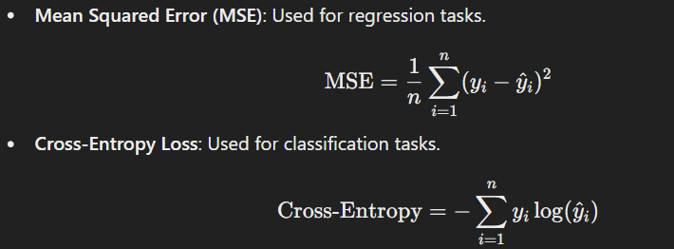

# Artificial Neuron Activation and Output Characteristics

An **artificial neuron** is the fundamental building block of a neural network. It mimics the functioning of a biological neuron by taking weighted inputs, applying an activation function, and producing an output.

# Diagram of an Artificial Neuron

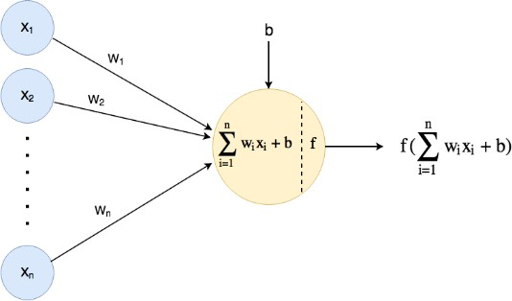

# Explanation of an Artificial Neuron

An artificial neuron operates in three main steps:

# Input and Weighted Sum

Each neuron receives multiple inputs (x1,x2,…,xnx_1, x_2, \dots, x_n) with associated weights

(w1,w2,…,wnw_1, w_2, \dots, w_n) and computes a weighted sum of these inputs along with a bias term (bb):

z=∑i=1nwixi+bz = \sum_{i=1}^{n} w_i x_i + b

This weighted sum zz is the input to the activation function.

# Activation Function

The **activation function** determines whether the neuron should be "activated" or not, introducing non-linearity to the model. Common activation functions are:

|  |  |  |  |  |
| --- | --- | --- | --- | --- |
| **Activation**  **Function** | **Equation** | | **Characteristics** | |
| **Linear** | f(z)=zf(z) = z | | No non-linearity, used for regression. | |
| **Sigmoid** | f(z)=11+e−zf(z) = \frac{1}{1 + e^{-z}} | | Output between 0 and 1, used for binary classification. | |
| **Tanh** | f(z)=ez−e−zez+e−zf(z) = \frac{e^z - e^{- z}}{e^z + e^{-z}} | | Output between -1 and 1, centered  around 0. | |
| **ReLU** | f(z)=max⁡(0,z)f(z) = \max(0, z) | Introduces sparsity, used in deep networks. | |

# Output

The output yy of the neuron is:

y=f(z)y = f(z)

This output is either passed to the next layer of neurons or used as the final output in the case of the output layer.

# Characteristics of Neuron Output Based on Activation Functions

* 1. **Linear Activation:**
     + No non-linearity, output increases linearly with input.
     + Used in the output layer of regression problems.

# Sigmoid Activation:

* + - Smooth curve, output ranges from 0 to 1.
    - Suitable for probability-based outputs (e.g., binary classification).
    - Vanishes gradients for large/small inputs.

# Tanh Activation:

* + - Output ranges from -1 to 1, centered at 0.
    - Better for models where negative values are significant.

# ReLU Activation:

* + - Outputs 0 for negative inputs and linear for positive inputs.
    - Commonly used due to simplicity and efficiency in deep learning.
    - Can suffer from the "dying ReLU" problem (neurons output 0 for all inputs).

**Neural Network Based Pattern Associators**

# **Neural Pattern Associators, and Function in Neural Networks for Pattern Recognition Tasks**

**Neural Pattern Associators** are a type of artificial neural network designed to map input patterns to corresponding output patterns. They are commonly used for pattern recognition, where the goal is to associate certain inputs (e.g., images, signals) with specific outputs (e.g., labels, categories). These networks work by learning the relationships between input-output pairs through a training process. A **Neural Pattern Associator** is a type of artificial neural network that is specifically designed to map one set of patterns (inputs) to another set of patterns (outputs). These are used for tasks where the goal is to recognize a pattern and provide a corresponding output, such as in image recognition, speech recognition, or classification tasks. In this context, **pattern association** refers to the ability of a neural network to recall the correct output (or associated pattern) given an input pattern.

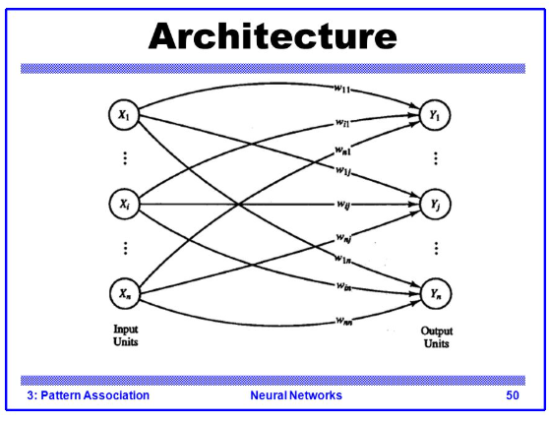

# Key Features of Neural Pattern Associators:

* + **Input Layer:** Represents the features of the input data (e.g., pixel values for images).
  + **Output Layer:** Represents the desired output, such as class labels or reconstructed patterns.
  + **Weights:** Connections between the input and output layers. These weights are adjusted during training to minimize error and improve pattern association.
  + **Learning Process:** Typically employs supervised learning using algorithms like gradient

descent. The network iteratively adjusts its weights based on the error between predicted and actual outputs.

# Functioning in Pattern Recognition Tasks:

1. **Training Phase:**
   * The network is presented with labeled input-output pairs.
   * The weights are updated to minimize the difference between predicted and actual outputs.

# Testing/Inference Phase:

* + New input patterns are presented to the trained network.
  + The network uses learned weights to produce associated outputs.

# Generalization:

* + The network should be able to correctly associate unseen patterns that are similar to those encountered during training.

For example, in image recognition, a neural pattern associator can learn to associate pixel patterns (input) with object categories (output).

# **Character Classification Using a Pattern Associator**

**Character classification** involves identifying and labeling handwritten or printed characters. Neural pattern associators perform this task by learning to map visual patterns (characters) to their respective labels (e.g., 'A', 'B', 'C').

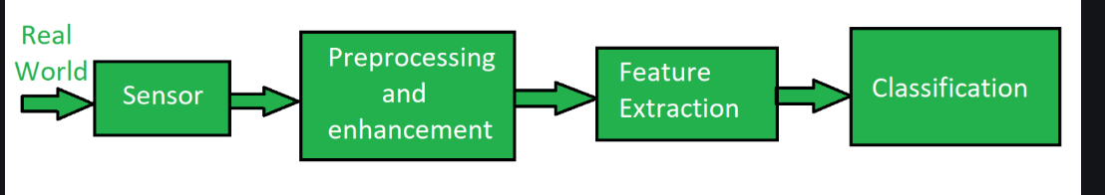

# Process of Character Classification:

1. **Preprocessing the Input:**
   * Characters are typically converted into a standard format, such as grayscale images or binary pixel arrays.
   * Features are extracted from these images, such as pixel intensities or edge patterns.

# Training the Associator:

* + Each character pattern (input) is paired with a corresponding class label (output).
  + The associator is trained using these pairs, adjusting weights to minimize classification errors.

# Association Mechanism:

* + During training, the network learns to map specific patterns to class labels by adjusting its weights.
  + For instance, a pixel array corresponding to the character 'A' is associated with the label 'A'.

# Classification Process:

* + In the inference phase, the network takes a new character image as input.
  + The pattern associator processes the input and assigns a label to it based on the learned associations.
  + For example, given an unseen image of 'B', the network outputs the label 'B' if trained correctly.

# Evaluation:

The performance of the character classification system is evaluated using metrics like:

* **Accuracy:** Percentage of correctly classified characters.
* **Precision and Recall:** To assess how well the system distinguishes between similar characters.

# Advantages:

* Can handle noisy or distorted characters.
* Learns directly from examples without requiring manual feature engineering.

# Example Application:

Optical Character Recognition (OCR) systems use neural pattern associators to convert scanned documents into editable text by classifying character images.

### ****Matrix Approaches (Linear Associative Mappings)****

In pattern recognition, **matrix approaches** to **linear associative mappings** (LAM) are methods used to find a linear relationship between input and output patterns. This approach uses matrices to represent the patterns and their relationships, allowing us to map inputs to outputs through linear transformations.

Linear associative mapping is a concept where an input pattern is mapped to an output pattern by applying a linear transformation, often represented in matrix form. This type of mapping is useful in various tasks, including classification, prediction, and even in certain types of neural network training.

### ****Key Concepts of Matrix Approaches****

* **Linear Transformation**: The transformation between input and output patterns is assumed to be linear, i.e., it can be represented by matrix multiplication.
* **Input-Output Matrix Representation**: Both input and output patterns are represented as vectors or matrices. The transformation between these matrices is achieved through multiplication by a weight matrix.
* **Matrix Equation**: The relationship between the input vector x and the output vector y can be expressed as:
  + - y=XW

Where:

X is the matrix of input vectors (data).

W is the matrix of weights (linear transformation coefficients).

y is the matrix of output vectors (resulting patterns)

The goal is to learn the weight matrix W so that it transforms input patterns to output patterns correctly.

### ****How Matrix Approaches Work****

### 

### 

### ****Applications****:

1. **Classification**: Used for supervised learning to map input features to categories.
2. **Regression**: Mapping inputs to continuous outputs.
3. **Signal Processing**: Tasks like noise reduction and signal transformation.
4. **Data Compression**: Using matrix decomposition techniques like SVD.
5. **Image Recognition**: Mapping features of images to labels.

# Question Reasons to Adopt a Neural Computational Architecture

1. **Ability to Learn and Generalize from Data:** Neural networks excel in learning directly from raw data without the need for extensive feature engineering. By identifying patterns and relationships in the data during the training phase, they can generalize well to unseen data, making them highly adaptable to new and dynamic environments. This learning capability is especially important in tasks like speech recognition, image classification, and natural language processing, where traditional algorithms may struggle.
2. **Handling Non-Linear and Complex Relationships:** Neural networks are designed to capture non-linear and complex interactions between variables that traditional linear models cannot handle. By utilizing non-linear activation functions such as ReLU, Sigmoid, or Tanh, they

transform input data through multiple layers to extract intricate features. This ability to model complex relationships makes them suitable for tasks like predicting weather patterns, financial market trends, or even human behavior.

1. **Versatility Across Domains:** Neural computational architectures are highly versatile and can be applied across diverse fields, including healthcare, finance, robotics, and entertainment. In healthcare, for instance, neural networks are used for early diagnosis of diseases,

analyzing medical images, and predicting patient outcomes. In finance, they are leveraged for fraud detection, risk assessment, and credit scoring. This cross-domain applicability makes them a preferred choice for solving a wide range of problems.

1. **Scalability and Flexibility:** Neural networks are inherently scalable and can be customized to fit specific problem requirements. They can be scaled up by increasing the number of layers (deep learning) or the number of neurons per layer, allowing them to tackle more complex problems. Furthermore, different architectures like Convolutional Neural Networks (CNNs) for image processing, Recurrent Neural Networks (RNNs) for sequential data, and

Transformers for language tasks offer flexibility in their design and application.

1. **Robustness to Noisy Data:** Neural networks are capable of handling noisy, incomplete, or unstructured data better than many traditional algorithms. They can learn to focus on

relevant patterns while ignoring irrelevant or noisy information, making them ideal for applications like speech recognition, where background noise is a common issue, or in financial markets, where data is often noisy and unpredictable.

1. **Support for Parallel and Distributed Processing:** Modern neural networks, particularly deep learning models, can leverage parallel and distributed computing environments, such as

GPUs and cloud computing platforms, to process large datasets efficiently. This parallelism reduces training time significantly and enables the deployment of large-scale models for

tasks like real-time object detection, autonomous driving, and large-scale recommendation systems, making neural computational architectures highly efficient and scalable for

industrial applications.

### ****Characteristics of Neural Computing Applications****

1. **Ability to Handle Non-Linear Problems**
   * Neural networks excel at solving **non-linear and complex relationships** that traditional models struggle with.
   * By using **activation functions** like ReLU, Sigmoid, or Tanh, neural networks introduce non-linearity, enabling them to model real-world data.
2. **Learning from Data**
   * Neural networks **learn patterns** and relationships automatically from data without requiring explicit programming.
   * They adapt their **weights and biases** during the training process to minimize error and improve predictions.
3. **Robustness to Noise and Incomplete Data**
   * Neural computing applications are **resilient to noisy, missing, or irrelevant data**.
   * Through training, they generalize well and can extract meaningful patterns, even in imperfect data.
4. **Parallel Distributed Processing**
   * Neural networks perform computations in a **parallel and distributed manner**.
   * Each neuron in a layer processes its input independently, making neural networks computationally efficient for large-scale data.
5. **High-Dimensional Data Handling**
   * Neural networks can handle **high-dimensional and unstructured data**, such as images, text, or sensor data.
   * Techniques like **convolutional layers** (CNNs) for image data or **embeddings** for textual data enable them to process complex inputs effectively.
6. **Generalization Capability**
   * After sufficient training, neural networks can **generalize** to unseen data, allowing them to make accurate predictions on new inputs.
   * This characteristic is particularly useful for tasks like classification and regression.
7. **Adaptability and Flexibility**
   * Neural networks are highly adaptable and can be applied to a **wide variety of domains**:
     + Image and speech recognition
     + Natural Language Processing (NLP)
     + Predictive analytics
     + Robotics and control systems
8. **Black Box Nature**
   * Neural networks act as **"black boxes"**, meaning their decision-making processes are complex and opaque.
   * While they are highly accurate, interpreting **how and why** decisions are made can be difficult, especially in critical applications like healthcare or finance.
9. **Scalability**
   * Neural networks are **scalable** and can be applied to both small and large datasets.
   * Modern computing techniques (e.g., GPUs and cloud computing) allow neural networks to scale efficiently for **big data** applications.

# CAM (Content Addressable Memory) and Other Neural Memory Structures

Neural networks often require **memory structures** to enhance their ability to learn, store, and retrieve information. These memory mechanisms allow models to handle complex tasks such as sequence prediction, reasoning, and pattern matching.

# Content Addressable Memory (CAM)

**Content Addressable Memory (CAM)**, also known as **associative memory**, is a type of memory that retrieves data based on the content rather than the address.

# Key Characteristics of CAM:

* + **Data is retrieved by matching content:** Unlike traditional memory, where data is accessed by its location, CAM searches for and retrieves data based on input patterns.
  + **Parallel Search:** CAM performs a parallel search across all memory locations, making it faster than traditional memory.
  + **Associative Retrieval:** It is often used to store key-value pairs, and when a key or partial pattern is presented, the corresponding value is retrieved.

# Diagram of CAM Structure

* + **Input Pattern:** The data pattern used to query the memory.
  + **Memory Cells:** Store patterns and their corresponding output.
  + **Matching Unit:** Compares input patterns with stored patterns.
  + **Output:** Returns the data corresponding to the matched pattern.

# Applications of CAM:

1. **Cache Memories:** CAM is used in associative caches to match tags with stored memory locations.
2. **Neural Networks:** Associative memories like Hopfield networks or Kohonen self-organizing maps are used for pattern recognition.
3. **Routers:** Used in network routers for fast lookups of IP addresses or MAC tables.

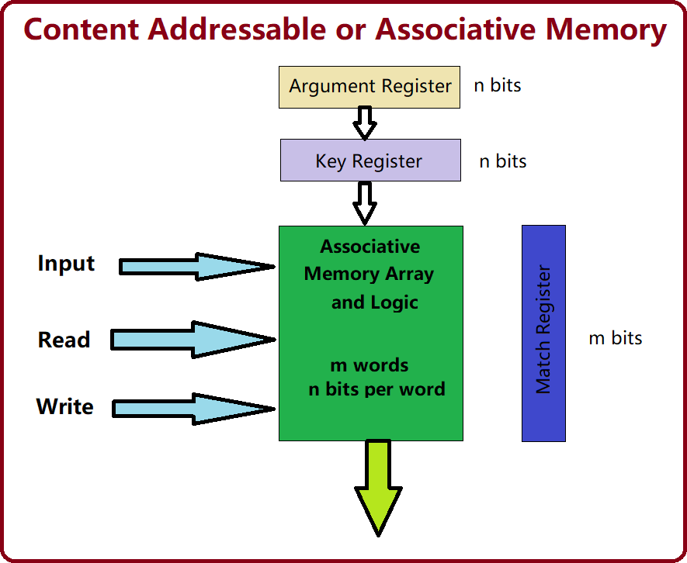

# Neural Memory Structures

Several other memory structures are used in neural networks, particularly in models that require long-term dependencies, pattern storage, or associative learning.

# Hopfield Networks

* + A recurrent neural network with binary threshold neurons that act as associative memory systems.
  + **Energy-Based Model:** The network converges to a stable state by minimizing an energy function.
  + **Use Case:** Pattern recognition and noise removal.

# Kohonen Networks (Self-Organizing Maps)

* + A type of unsupervised learning neural network that organizes data into a lower-dimensional map.
  + **Feature Mapping:** The network clusters and maps similar input patterns to nearby neurons.
  + **Use Case:** Data visualization, clustering, and pattern matching.

# Long Short-Term Memory (LSTM) Networks

* + A type of recurrent neural network (RNN) designed to handle **long-term dependencies** by using memory cells.
  + **Gates:** LSTMs use input, forget, and output gates to control information flow.
  + **Use Case:** Sequence prediction, language modeling, and time-series forecasting.

# Memory-Augmented Neural Networks (MANNs)

* + Neural networks augmented with an external memory matrix.
  + **Read and Write Operations:** The network can read from and write to external memory, similar to how a computer operates.
  + **Example:** Neural Turing Machines and Differentiable Neural Computers.
  + **Use Case:** Complex reasoning tasks, question answering, and algorithm learning.

# Transformer Networks (Attention Mechanism)

* + **Attention Mechanism:** A memory structure that allows the network to focus on relevant parts of the input data.
  + **Self-Attention:** Computes a weighted sum of all input elements, focusing on important ones.
  + **Use Case:** Language translation, text generation, and image captioning.

# Comparison of Neural Memory Structures

|  |  |  |  |
| --- | --- | --- | --- |
| **Memory Structure** | **Type** | **Primary Use** | **Key Feature** |
| **Content Addressable Memory** | Associative | Fast lookups, caching | Parallel search and retrieval |
| **Hopfield Networks** | Associative | Pattern recognition | Converges to stable patterns |
| **Kohonen Networks** | Associative | Clustering, feature mapping | Unsupervised learning |
| **LSTM Networks** | Sequential | Time-series prediction | Long-term memory control |
| **Memory-Augmented Neural Networks** | External Memory | Complex reasoning | External memory matrix |
| **Transformer Networks** | Attention | NLP tasks, translation | Focused attention mechanism |

### ****Neural Networks as a Black Box Approach****

1. **Definition of Neural Networks as a Black Box**:
   * Neural networks are often called a "black box" because their internal processes are difficult to understand or interpret.
   * While they automatically learn from data, their decision-making processes remain opaque.
2. **Structure of Neural Networks**:
   * Composed of **multiple layers** of interconnected **neurons**.
     + **Input Layer**: Accepts input data.
     + **Hidden Layers**: Perform mathematical operations to transform inputs.
     + **Output Layer**: Provides predictions.
   * Neurons apply weights, biases, and activation functions to process data.
3. **Training Phase**:
   * The network learns patterns and adjusts internal parameters (**weights** and **biases**) to minimize prediction errors.
   * Techniques used for training include:
     + **Gradient Descent**: Optimizes weights to reduce loss (error).
     + **Backpropagation**: Adjusts weights by propagating errors backward from output to input.
4. **Reason for Black Box Nature**:
   * Neural networks involve **complex operations** and a **large number of parameters**.
   * It is difficult to trace how specific inputs result in specific outputs due to the network's non-linear transformations.
5. **Strengths of Neural Networks**:
   * **Excels at Complex Problems**: Effective where traditional algorithms fail.
   * **Tasks**:
     + **Image Recognition**: Detects objects and patterns in images.
     + **Natural Language Processing (NLP)**: Processes and understands human language.
     + **Predictive Analytics**: Predicts future trends or outcomes.
   * **Ability**: Models non-linear, high-dimensional relationships and uncovers intricate patterns invisible to simpler models.
6. **Challenges with Black Box Nature**:
   * Lack of transparency raises concerns in **critical domains** where interpretability is crucial:
     + **Healthcare**: Stakeholders need to understand why a disease is predicted.
     + **Finance**: Ensures decisions are reliable, unbiased, and accountable.
     + **Autonomous Systems**: Safety and trust depend on understanding AI behavior.
7. **Efforts to Improve Interpretability**:
   * Researchers are developing **Explainable AI (XAI)** techniques to address the black box issue.
   * **XAI Techniques**:
     + Provide insights into **how data is processed**.
     + Identify **important features** influencing predictions.
     + Explain relationships between input and output.
8. **Ongoing Challenge**:
   * Balancing high performance with interpretability remains a key area of research in AI.
   * Perfect transparency without compromising accuracy is yet to be achieved.
9. **Conclusion**:
   * Neural networks offer significant predictive power and flexibility.
   * However, their black box nature continues to be a challenge, especially in domains requiring trust, accountability, and transparency.

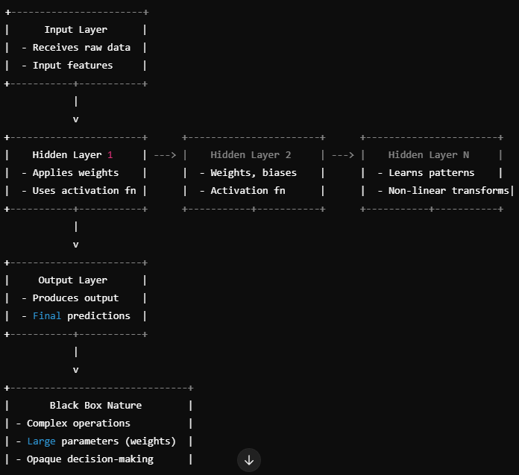

**UNIT 6**

# Structure of a Multiple Layer Feedforward Network

A **Multiple Layer Feedforward Network (MLFN)** is a type of artificial neural network (ANN) where the information flows in one direction, from the input layer to the output layer, passing through one or more hidden layers. This network is also known as a **Multilayer Perceptron (MLP)**.

# Diagram of a Multiple Layer Feedforward Network

* **Input Layer** with 3 neurons
* **Hidden Layer** with 4 neurons
* **Output Layer** with 2 neurons

The connections between layers will illustrate the flow of information from the input to the output layer.

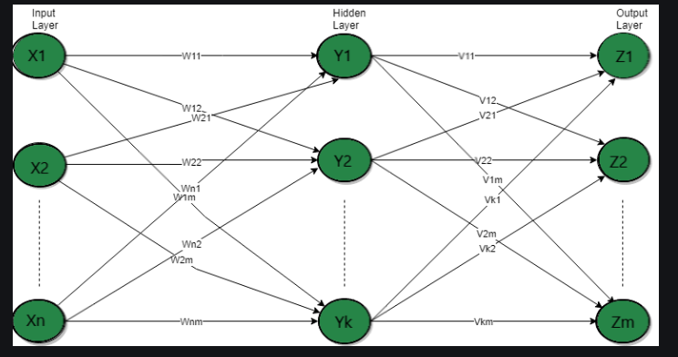

# Explanation of a Multiple Layer Feedforward Network

A Multiple Layer Feedforward Network typically consists of the following components:

# Input Layer:

* + The first layer of the network.
  + Receives the raw input data.
  + Each neuron in the input layer represents a feature of the input data.
  + Example: If predicting laptop prices, input features could be RAM size, processor speed, and storage capacity.

# Hidden Layer(s):

* + One or more intermediate layers between the input and output layers.
  + Each neuron in the hidden layer applies a weighted sum of its inputs followed by an activation function (e.g., ReLU, Sigmoid, or Tanh).
  + Purpose:
    - Capture complex patterns in the data.
    - Perform transformations on the input data to learn non-linear relationships.
  + More hidden layers increase the network's capacity to model complex relationships, but also increase the risk of overfitting.

# Output Layer:

* + The final layer of the network.
  + Produces the output of the network.
  + Each neuron in this layer corresponds to a possible output.
  + Example: In a classification task, each output neuron might represent a different class.

# Working of the Network:

1. **Forward Propagation:**
   * Data flows from the input layer through the hidden layers to the output layer.
   * Each neuron computes a weighted sum of its inputs and applies an activation function.

# Weight Updates:

* + After forward propagation, weights are updated using **backpropagation** to minimize the error between predicted and actual outputs.

# Activation Functions:

* + Non-linear activation functions (e.g., ReLU, Sigmoid) are used in hidden layers to allow the network to learn complex patterns.

# Advantages:

* Can model complex and non-linear relationships.
* Suitable for tasks like classification, regression, and feature extraction.

# Disadvantages:

* Requires large datasets and computational power.
* Risk of overfitting if not properly regularized.
* Training can be time-consuming and requires careful tuning of hyper parameters.

### Training a Feedforward Network using the Generalized Delta Rule (Backpropagation)

The **Generalized Delta Rule**, also known as the **Backpropagation Algorithm**, is used to train feedforward neural networks by minimizing the error between the predicted and actual outputs. This method employs **gradient descent** to adjust the weights of the network.

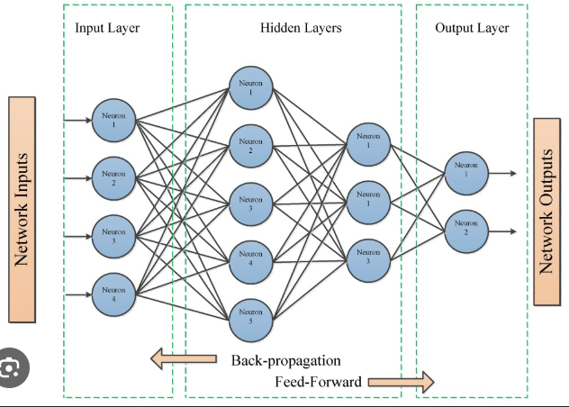

### ****Explanation: Training a Feedforward Neural Network Using the Generalized Delta Rule****

The training process involves two main phases: **Forward Propagation** and **Backward Propagation of errors** using the Generalized Delta Rule. Here's a step-by-step explanation:

### 

### 

### ****Extension of the Dimensionality Reduction (DR) for Units in the Hidden Layers****

In neural networks, **Dimensionality Reduction (DR)** techniques can be applied to the **hidden layers** to optimize network performance, improve efficiency, and enhance generalization. DR aims to reduce the number of neurons (units) in the hidden layers without significantly affecting the model's accuracy. This is particularly useful for managing large models or datasets with high-dimensional features.

### ****Techniques for Dimensionality Reduction in Hidden Layers****

1. **Principal Component Analysis (PCA)**
   * PCA is a statistical technique that transforms input features into a smaller set of **principal components** that capture most of the variance.
   * Applied to hidden layers, PCA can reduce the number of neurons by projecting the data into a **lower-dimensional space**.
   * This helps to eliminate redundant and less significant features.

**Key Benefits**:

* + Reduces computational complexity.
  + Improves training time.
  + Minimizes overfitting.

1. **Singular Value Decomposition (SVD)**
   * SVD decomposes a matrix into three components: U, Σ (singular values), and V.
   * For hidden layers, SVD can approximate the weight matrices, reducing their rank and dimensionality while preserving important information.

**Key Benefits**:

* + Reduces the number of connections and parameters in the network.
  + Accelerates forward and backward propagation.

1. **Auto encoders for Compression**
   * An **autoencoder** is a type of neural network that learns an efficient, lower-dimensional representation of the data.
   * The bottleneck layer (latent space) compresses high-dimensional inputs into fewer neurons.
   * In hidden layers, using an autoencoder can pre-train the network or optimize the units by learning compressed features.

**Key Benefits**:

* + Reduces unnecessary neurons.
  + Learns compact, informative features.
  + Useful for pre-training deep networks.

1. **Regularization Techniques**
   * Techniques like **Dropout** and **L1/L2 Regularization** can implicitly reduce the dimensionality of hidden layers:
     + **Dropout** randomly deactivates neurons, leading the model to focus only on critical units.
     + **L1 Regularization** encourages sparsity in the hidden layer by penalizing non-zero weights, effectively reducing the number of active neurons.

**Key Benefits**:

* + Reduces overfitting.
  + Forces the model to rely on a smaller set of important neurons.
  + Improves generalization.

1. **Pruning of Neurons**
   * Pruning involves **removing neurons or connections** in hidden layers that contribute minimally to the overall output.
   * Methods include:
     + **Magnitude-Based Pruning**: Removes weights with small magnitudes.
     + **Iterative Pruning**: Gradually removes insignificant neurons during training.

**Key Benefits**:

* + Reduces model size.
  + Speeds up inference time.
  + Optimizes resource usage.

1. **Low-Rank Factorization**
   * Hidden layer weight matrices can be factorized into **low-rank approximations** to reduce dimensionality.
   * Instead of a full weight matrix, the product of two smaller matrices can approximate the original weights.

**Key Benefits**:

* + Reduces the number of parameters.
  + Maintains accuracy with fewer computations.

### ****Impact of DR on Hidden Layers****

* **Faster Training and Inference**: Fewer neurons reduce computation time for both forward and backward passes.
* **Reduced Overfitting**: Simplifies the network to focus on key patterns, improving generalization.
* **Memory Efficiency**: Lower dimensionality reduces the storage needed for weights and activations.
* **Improved Interpretability**: Fewer units make the network easier to analyze and understand.

### ****Challenges of DR in Hidden Layers****

* Risk of **Information Loss** if too many neurons are removed.
* Over-reduction may **hurt accuracy** and learning capacity.
* Requires careful selection of techniques and tuning to maintain performance.

# Self-Organizing Networks: A Primer

Self-Organizing Networks (SONs), often referred to as Self-Organizing Maps (SOMs), are a type of artificial neural network that learns to classify input data without the need for labeled training examples. This unsupervised learning technique is particularly effective in pattern recognition tasks, as it can automatically discover underlying structures and relationships within data.

# Primary Functions of Self-Organizing Networks:

1. **Dimensionality Reduction:** SOMs can reduce the dimensionality of high-dimensional data while preserving its topological structure. This is achieved by mapping input data onto a lower-dimensional grid of neurons, where similar inputs are mapped to neighboring neurons.
2. **Clustering and Classification:** By organizing neurons into clusters, SOMs can identify natural groupings within data. This clustering capability is valuable for tasks like customer segmentation, image analysis, and anomaly detection.
3. **Feature Extraction:** SOMs can extract relevant features from input data. This is particularly useful in applications where the underlying features are not explicitly known or defined.
4. **Visualization:** SOMs provide a visual representation of the data distribution, allowing for easy interpretation and analysis. This visualization can help identify patterns, trends, and outliers.

# Applications of Self-Organizing Networks in Pattern Recognition:

1. **Image and Signal Processing:**
   * Image segmentation: Dividing images into meaningful regions based on texture, color, or intensity.
   * Feature extraction: Identifying relevant features from images, such as edges, corners, and textures.
   * Noise reduction: Filtering out noise from images or signals.

# Data Mining and Knowledge Discovery:

* + Clustering: Grouping similar data points together to identify patterns and trends.
  + Anomaly detection: Identifying unusual data points that deviate from normal patterns.
  + Association rule mining: Discovering relationships between different variables in a dataset.

# Bioinformatics:

* + Protein structure analysis: Identifying protein families and functional sites.
  + Gene expression analysis: Clustering genes with similar expression patterns.

# Financial Analysis:

* + Customer segmentation: Grouping customers based on their behavior and preferences.
  + Stock market analysis: Identifying trends and patterns in stock prices.

# Robotics:

* + Sensor data analysis: Interpreting sensor data to make decisions about robot actions.
  + Learning and adaptation: Enabling robots to learn from their environment and adapt to new situations.

# How Self-Organizing Networks Work:

1. **Initialization:** A grid of neurons is created, and their weights are initialized randomly.
2. **Competitive Learning:** An input vector is presented to the network, and each neuron calculates its distance to the input. The neuron with the smallest distance is the "winner."
3. **Weight Update:** The weights of the winning neuron and its neighbors are updated to be more similar to the input vector.
4. **Iteration:** This process is repeated for multiple iterations with different input vectors, gradually organizing the neurons into clusters that represent different patterns in the data.

By leveraging their ability to learn from unlabeled data and discover hidden patterns, self-organizing networks have become a powerful tool in a wide range of pattern recognition applications.

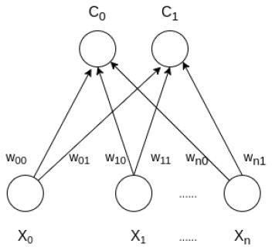

### Advantages of SOM:

* **Topology Preservation:** SOM maintains the topological relationships between data points, making it effective for clustering and visualization.
* **Unsupervised Learning:** It works well with unlabeled data.
* **Nonlinear Dimensionality Reduction:** SOM can reduce the complexity of data without losing essential relationships between data points.

### Limitations of SOM:

* **Sensitive to Initialization:** The outcome of SOM can depend on the initial weight values.
* **Requires Preprocessing:** Data needs to be normalized or standardized to ensure efficient learning.
* **Computational Complexity:** SOM can be computationally intensive, especially for large datasets with high dimensionality.

**Adaptive Resonance Theory (ART)**

**Adaptive Resonance Theory (ART)** is a class of neural network models designed to solve the **stability-plasticity dilemma**, which refers to the challenge of learning new patterns without forgetting previously learned patterns. ART networks are particularly well-suited for **unsupervised learning** tasks such as **pattern recognition**, **clustering**, and **incremental learning**.

### Key Features of ART:

1. **Stability and Plasticity:**
   * **Stability:** Once a pattern is learned, the network should not forget it when learning new patterns.
   * **Plasticity:** The network should be able to learn new patterns without needing to retrain from scratch.
2. **Resonance:**
   * The concept of **resonance** refers to the network's ability to "match" or "resonate" an input pattern with an existing category. If the input pattern is sufficiently similar to an existing category, it is classified under that category. Otherwise, a new category is created.
3. **Category Formation:**
   * ART networks dynamically create new categories as needed. When a new input doesn't match any existing category, the network forms a new category for it.
4. **Vigilance Mechanism:**
   * The **vigilance parameter** controls how strictly an input must match an existing category. If the similarity between an input and an existing category is above the vigilance threshold, it is classified into that category. If not, a new category is formed.

### Architecture of ART:

### 

• **Input Layer:** Receives the incoming data or patterns that need to be categorized.

• **Comparison Layer:** Compares the input pattern to stored patterns and triggers a match if the input is sufficiently close to a category.

• **Category Layer:** Represents the category or cluster of the input data. If the input matches an existing category, the category is updated; otherwise, a new category is created.

• **Vigilance Mechanism:** Ensures that a new input pattern only joins an existing category if it meets a certain similarity threshold. If not, a new category is formed.

### • **Feedback Loops:** Adjust the weights of the network to reinforce correct categorization and adapt as new patterns are learned. This is part of the network's learning mechanism.

### Types of ART:

1. **ART1:** For binary pattern recognition.
2. **ART2:** For continuous-valued input patterns.
3. **ART3:** An extension that handles both discrete and continuous inputs, useful for time-series or sequence recognition tasks.
4. **Fuzzy ART:** For handling fuzzy sets, useful for imprecise data.

### Applications:

* **Pattern Recognition:** ART networks are often used in situations where patterns need to be identified in noisy or unstructured data.
* **Clustering:** ART can perform clustering of input data into categories, making it useful for **unsupervised learning**.
* **Incremental Learning:** ART is ideal for environments where data is continually being introduced, and the system needs to learn continuously without forgetting prior knowledge.
* **Anomaly Detection:** ART networks can identify outliers in data, making them useful for detecting novel patterns or abnormalities.

# Summary of the Backpropagation Learning Procedure

Backpropagation (short for **"backward propagation of errors"**) is a supervised learning algorithm widely used for training artificial neural networks. It calculates the gradient of the loss function with respect to each weight by the chain rule, propagating the error backward through the network.

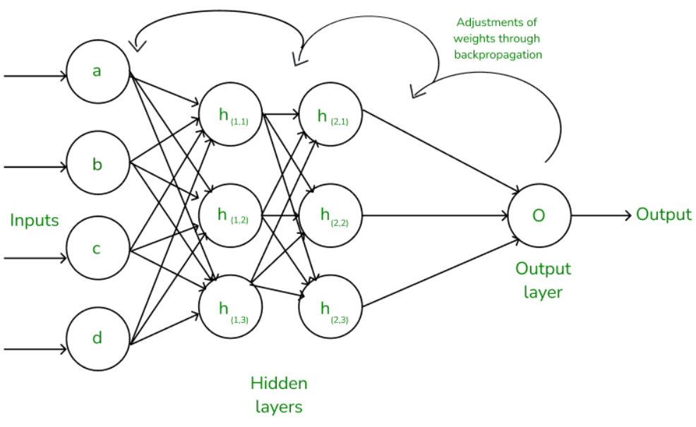

# Explanation of Backpropagation Learning Procedure

The backpropagation process consists of two main phases:

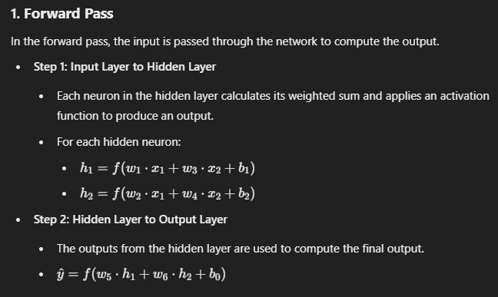

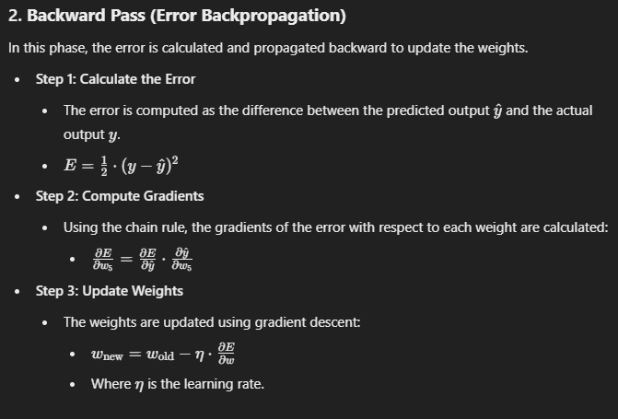

# 3. Key Steps in Backpropagation:

1. **Forward pass:** Compute output by passing inputs through the network.
2. **Error computation:** Calculate the difference between predicted and actual output.
3. **Backward pass:** Propagate the error backward and compute gradients.
4. **Weight update:** Adjust the weights to minimize the error.

# Advantages:

* + Efficient for large networks.
  + Applicable to a variety of network architectures.

# Disadvantages:

* + Can get stuck in local minima.
  + Requires differentiable activation functions.